Natural Language Processing


Assignment 1+2: Problem Definition & Data Understanding
Course Instructor: Dr. Danish Javed
Student Name: Abdullah Javed
Student ID: F2023065162
Section: W-3

University of Management and Technology

1. Problem Description
Problem Statement
The objective of this project is to build a system that can automatically classify text messages as spam or ham (non-spam). Spam messages are unsolicited messages that often contain promotional content, fraudulent schemes, or malicious links.
This is a text classification problem in Natural Language Processing.
Importance of the Problem
Spam detection is an important real-world application of NLP.
- It helps protect users from fraud and phishing attacks
- It is widely used in platforms like Gmail and Outlook
- It reduces unwanted messages and improves user experience
- It serves as a foundational problem for understanding NLP techniques such as preprocessing and feature extraction

2. Dataset Description

Dataset Used
- Dataset: SMS Spam Collection Dataset
- Source:https://archive.ics.uci.edu/ml/datasets/sms+spam+collection

Dataset Details
- Total samples: 5572 messages
- Number of columns: 2
  - label → spam or ham
  - message → text content
- Classes:
  - Spam
  - Ham

Justification
This dataset is suitable because:
- It meets the requirement of having more than 5000 samples
- It represents a real-world problem (spam detection)
- It is ideal for understanding preprocessing techniques like stopword handling and text normalization
- It allows application of feature extraction methods such as TF-IDF and Bag of Words

3. Exploratory Data Analysis (EDA)
STEP 1: Loading Of Dataset
The dataset was loaded using pd.read_csv whereas the dataset is not in csv format but tab separated format so we have passed sep=’\t’ and header is set to none because there are no columns in dataset so It might not consider the top row of dataset as column. Two columns were created afterwards as “label” and “Message” indicating the class and text of the message. Head was also used to print first five rows of our dataset.
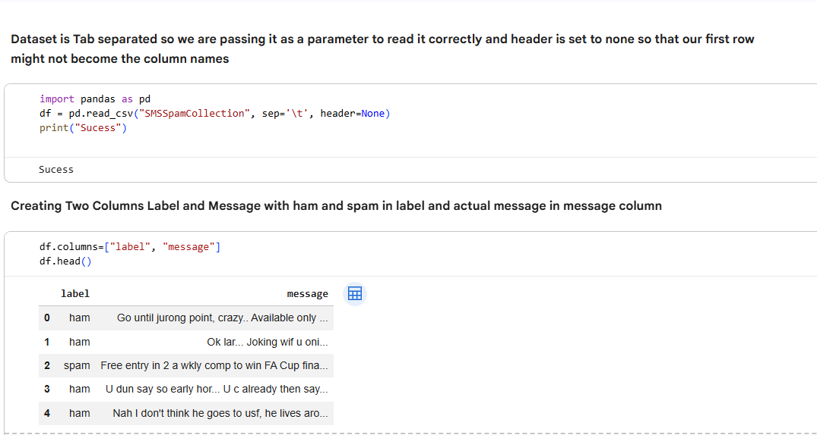
Step 2: Dataset Information
The dataset description is analyzed using df.info(), df.shape, and by viewing the dataset directly.
- The dataset contains 5572 rows and 2 columns, which satisfies the requirement of having more than 5000 samples.
- Both columns (label and message) have 5572 non-null values, indicating that there are no missing values in the dataset.
- The data type of both columns is object, which is expected since the dataset consists of textual data.
This confirms that the dataset is clean and ready for further analysis.

Step 3: Class Distribution
The distribution of classes was analyzed using value_counts().
- Ham messages ≈ 86%
- Spam messages ≈ 14%
This shows that the dataset is imbalanced, with a significantly higher number of ham messages compared to spam messages.
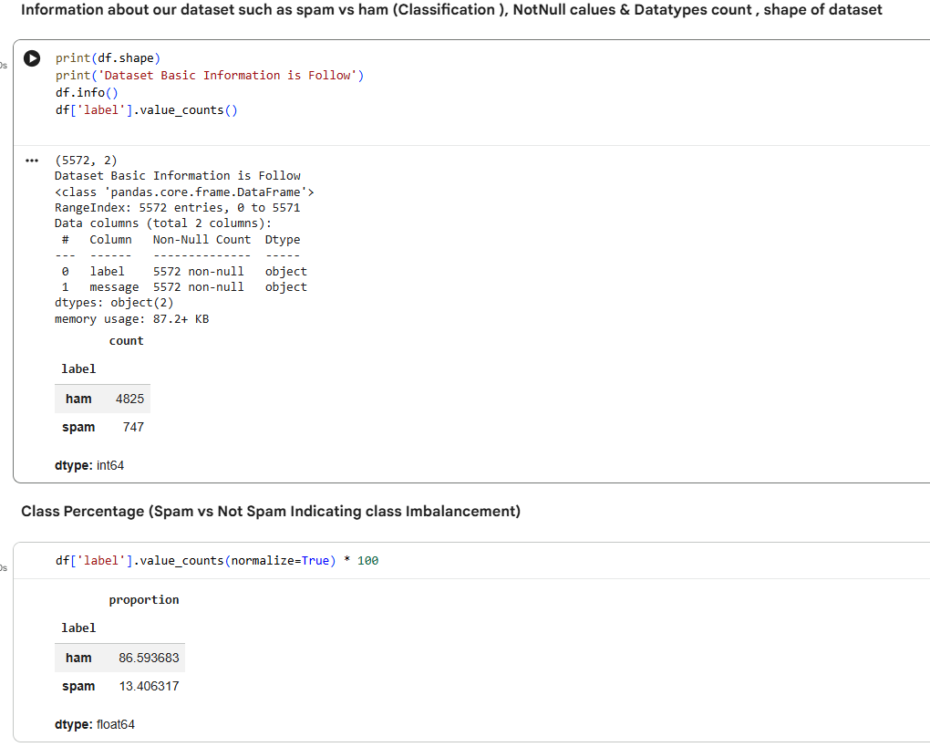
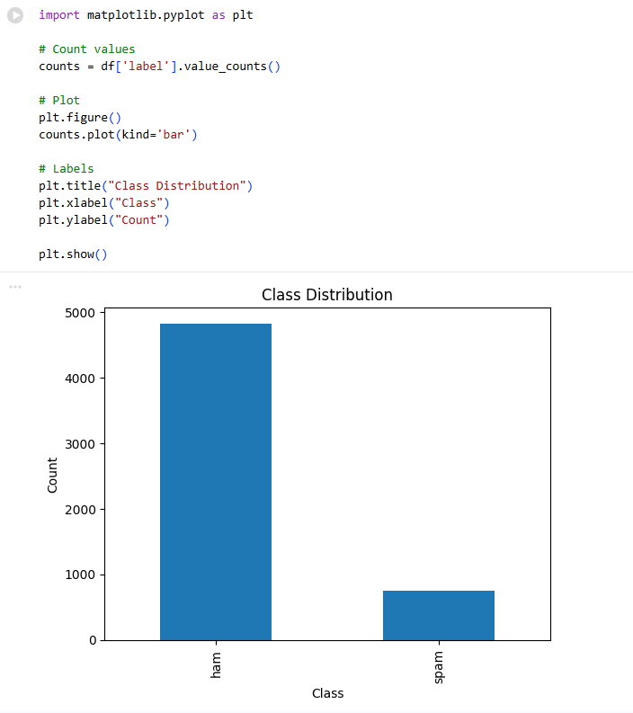

Observation:
The imbalance in the dataset indicates that most messages are normal (ham), while spam messages are relatively fewer.

Insight:
This imbalance can affect model performance, as the model may become biased toward predicting the majority class (ham). Therefore, this issue should be considered in later stages of modeling.

Step 4: Sample Data Analysis
A random sample of messages was displayed using df.sample(10) to understand the nature of the data.
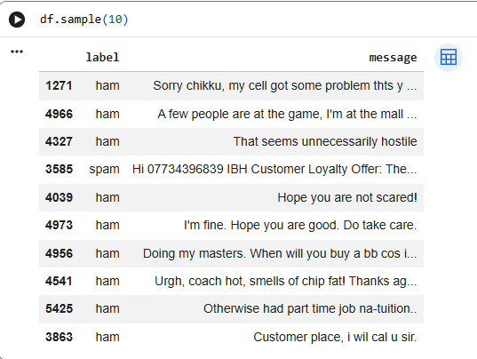
Observation:
- Spam messages often contain promotional words, phone numbers, or offers.
- Ham messages are generally conversational and informal in nature.
This difference in writing style helps in distinguishing between spam and non-spam messages.
Step 5: Vocabulary Size
The vocabulary size was calculated by combining all messages and splitting them into words.
- Total words: 86,909
- Unique words: 15,691
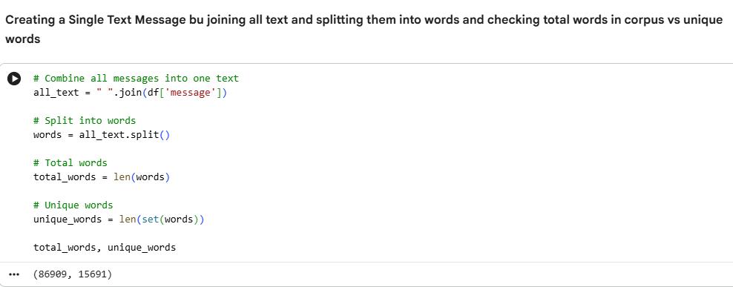

Observation:
The dataset contains a large and diverse vocabulary, with many unique words.
Insight:
A large vocabulary can lead to:
- High-dimensional feature space
- Sparse data representation
Therefore, preprocessing techniques such as stopword removal and lemmatization will be important to reduce noise and improve efficiency.
Step 6: Message Length Analysis
A new column message_length was created to analyze the length of each message.
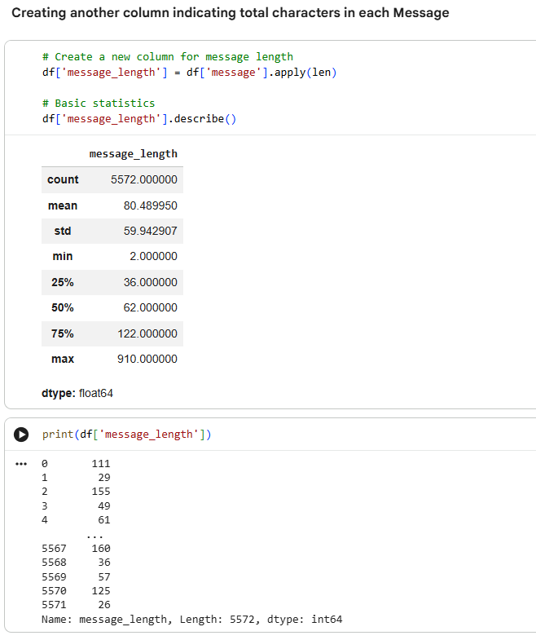
Observation:
- Messages vary significantly in length
- Spam messages tend to be more structured and sometimes longer
- Ham messages are generally shorter and conversational

Final Observations
The dataset shows clear differences between spam and ham messages in terms of language patterns, structure, and vocabulary. Additionally, the dataset is imbalanced and contains a large vocabulary, which highlights the importance of preprocessing and feature engineering in the next phase of the project.

4. Text Preprocessing
The raw text data was preprocessed to make it suitable for machine learning models. The following steps were applied:
Step 1: Storing Original Data
Before applying preprocessing techniques, the original text data was preserved by creating a separate column (original_message).
This step is important because preprocessing permanently modifies the text, and keeping the original data allows comparison and prevents loss of information.
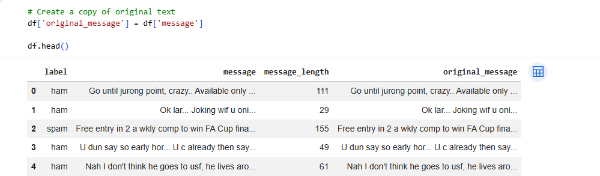
Step 2: Lowercasing
All text data was converted into lowercase using string operations.
This helps in maintaining uniformity by treating words like “Free”, “FREE”, and “free” as the same word, thereby reducing redundancy in the dataset.
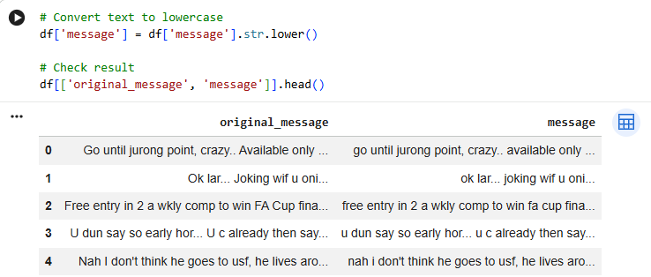
Step 3: Handling Special Characters
Special characters such as punctuation, symbols, and numbers were removed using regular expressions.
This step reduces noise in the dataset and simplifies the text for further processing.
However, it is important to note that numbers may sometimes contain useful information (such as phone numbers in spam messages), but they were removed as part of basic preprocessing.
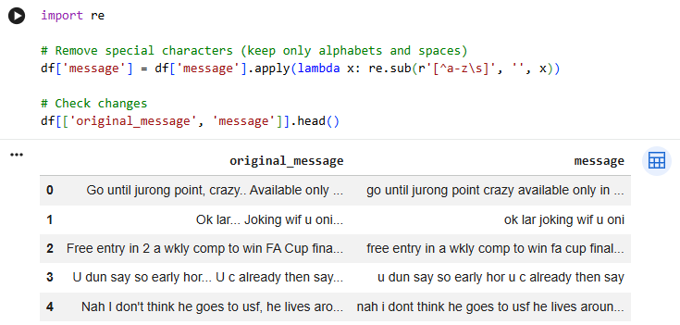
Step 4: Tokenization
Tokenization was performed by splitting each message into individual words.
This converts text into a list of words, allowing further processing at the word level.
Example:
"you won a free prize" → ["you", "won", "a", "free", "prize"]
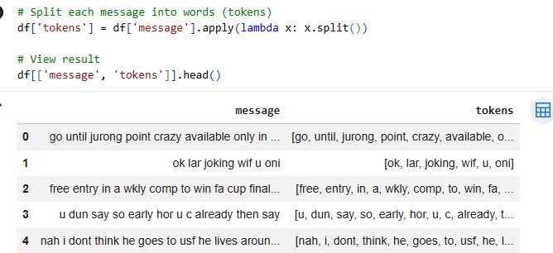
Step 5: Stopword Removal
Common words such as “the”, “is”, and “you” were removed using a predefined stopword list.
This helps reduce vocabulary size and focuses on meaningful words.
It is important to note that stopwords may sometimes carry contextual information, especially in spam detection, but they were removed to simplify the model.
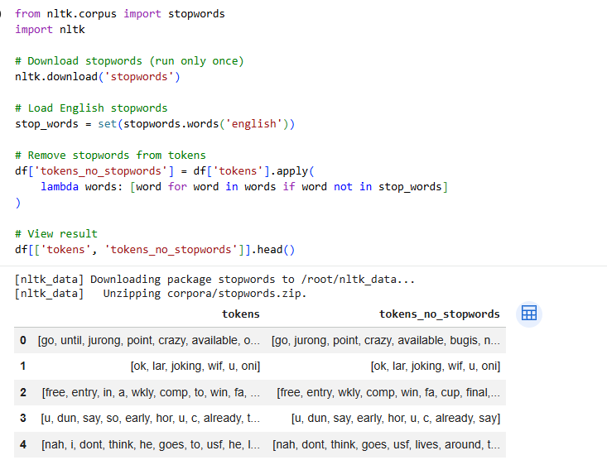
Step 6: Lemmatization
Lemmatization was applied to convert words into their base form.
Example:
"running" → "run"
"studies" → "study"
This helps in grouping similar words and reducing the vocabulary size.
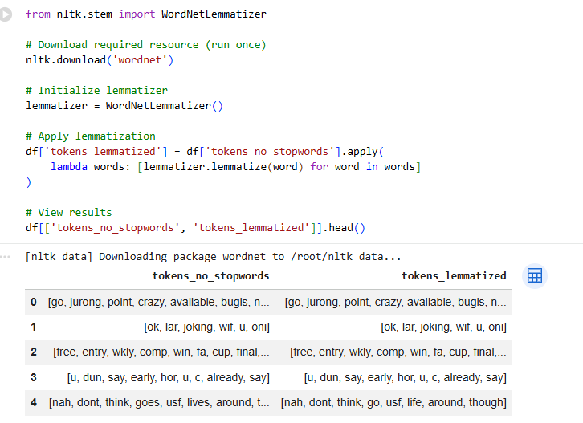
Step 7: Final Processed Text
After preprocessing, the tokens were joined back into a single text column called final_text.
This processed text was used for feature extraction.
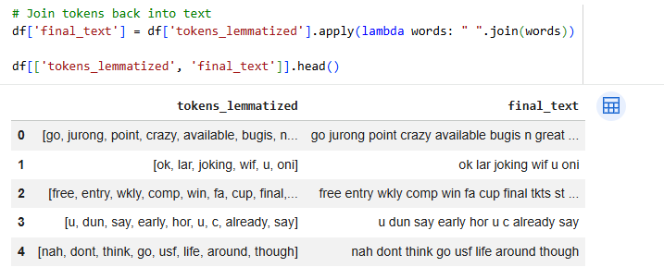
5. Feature Representation
Step 1: Bag of Words (BoW)
The Bag of Words model was used to convert text into numerical features by counting word occurrences.
- Feature size: 7950
This method is simple and effective but does not consider the importance of words.
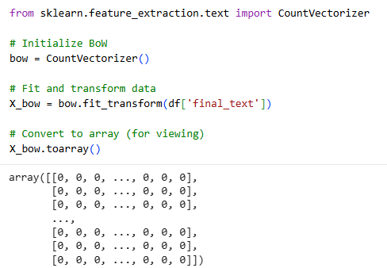

Step 2: TF-IDF
TF-IDF (Term Frequency – Inverse Document Frequency) was applied to assign importance to words based on their frequency.
- Feature size: 7950
Unlike BoW, TF-IDF reduces the weight of common words and highlights important words.
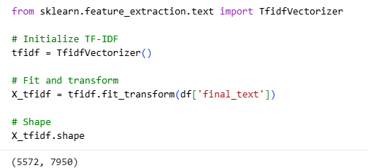
Step 3: Bigram Model
The bigram model was used to capture pairs of words instead of single words.
Example:
"free prize"
- Feature size: 30,349
This method captures context but increases dimensionality significantly.
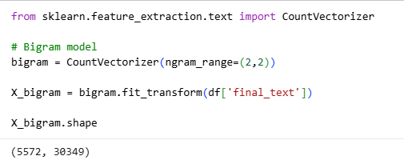

6. Feature Analysis
Step 1: Feature Size Comparison
Method | Number of Features
Bag of Words | 7,950
TF-IDF | 7,950
Bigrams | 30,349
Step 2: Observations
- Preprocessing significantly reduced vocabulary size
- TF-IDF and BoW have the same number of features but differ in weighting
- Bigram model produces a much larger feature space
Step 3: Key Insights
- Bag of Words is simple but does not capture importance
- TF-IDF improves representation by weighting important words
- Bigrams capture context but increase computational complexity
Final Conclusion
TF-IDF provides the best balance between performance and efficiency. While bigrams capture more contextual information, they result in a very large feature space, which can negatively affect performance due to sparsity.

